North Moors Allotments – Update for Full Council Meeting 13 August 2026
A quote was received from Scribe for the costs for the accounting module for managing the allotments.
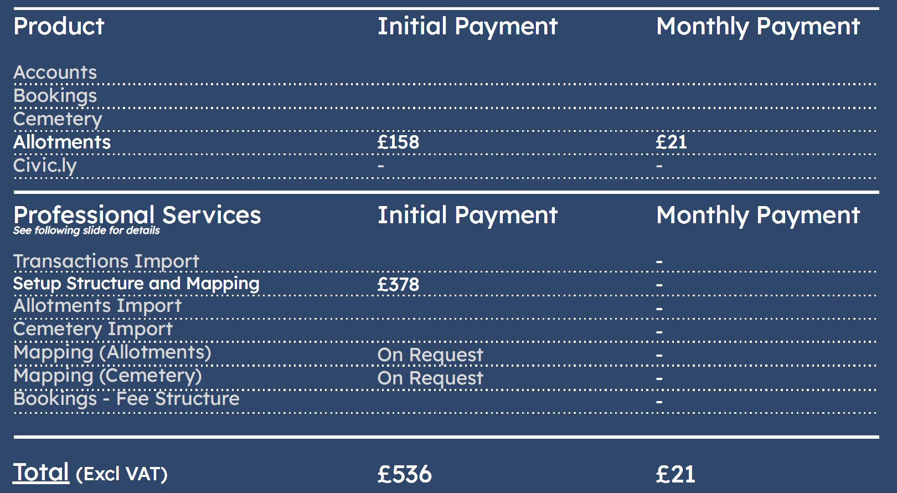
A response from Hendryk Jurk replying to the requests for additional information
Please can we get a detailed legal position statement from GBC regarding transfer options (lease vs freehold vs freehold partial boundary transfer). Members stated their preference for any transfer to be limited to the allotment site enclosed by the green security fencing and not the surrounding land, paths and trees.
- Please outline the Parish preference. We should be able to accommodate this.
Is there a breakdown of the utility costs and usage projections?
- Please note we have been able to track down a water bill. It is unreasonable to ask the Parish to pick up historic cost. I suggest that we agree the Borough will settle any outstanding bills. Estimate based on Allotment Society charges are £3.4/rod which is an average that should cover the cost by tenants. Fully occupied North Moors would be in the region of £2,000. But depends on use.
Do you have an estimate for building maintenance costs?
- These should be minimal as average. We have not incurred costs yet. But will try to get a surveyor's opinion. Assume £1,000/year. (I.e. £5,000 every 5 years).
Can you confirm the original fencing costs (to estimate repair costs).
- We don't have the information from the Project Team at present. Recent new fence at the Lido allotments was £40k. Metal fences seem to outlast a generation.
Can you confirm the original shed install costs (to estimate repair/replacement costs).
- No information from the Project Team at present.
Please can you provide further clarification on the financial position.
- The current financial shortfall and basis for this
- No update
- Detail of subsidy arrangements:
- We currently provide a grant to GACSL that equates to approx. £1,000 per allotment. To my knowledge at present this provides for running costs but also some contingency. I.e. Some water pipe replacements, fluctuations in water prices etc. I.e. Tenant fees + grant cover more than annual cost.
- An understanding on whether there would be a dowry received from Guildford Borough Council for ongoing management and maintenance of the site.
- We would like the Parish to outline expectations for discussion.
- Aside from the grant we do not have a specific budget for allotments because the replacement costs are infrequent. I.e. The new fence at the Lido allotments has been the only investment on existing allotments.

