

Minutes of the Full Council Meeting held in the
Council Chamber, Unit 2 Saxton, Parklands, Railton Road, Guildford, Surrey, GU2 9JX
at 19:30 on Thursday 2 July 2026

Present

Councillors:
Cllr B Ahier, Cllr G Burch, Cllr S Busby, Cllr N Crampin, Cllr N Mitchell (Chairman), Cllr B Nagle, Cllr M Price, Cllr C Riley, and Cllr T Wright.

Officers of the Council:
Mrs G White - Clerk to the Council (retiring)
Miss M Wingate - Clerk to the Council (in training)
Mrs V Fear - Assistant Clerk

Members of the public:
Guildford Borough Council & West Surrey Unitary Councillor B Akhtar, West Surrey Unitary Councillor J Steel (Guildford West), Surrey County Councillor K Witham, West Surrey Unitary Councillor J McShane (Guildford West), and Guildford Borough Councillor H Brooker were present for part of the meeting.

To accept apologies and reason for absence in accordance with the LGA 1972, Sch12, para 40
Apologies and reason for absence had been received from Cllr S Ellahi, Cllr B McShee, Cllr J Snowball, and Cllr R Watson. All apologies and reason for absence were accepted.
Apologies were also received from Borough Councillor P Brooker and West Surrey Unitary Authority Councillor J Lord.

Public participation session
No members of the general public were present.

Declaration of non-pecuniary interests in accordance with the Parish Council’s Code of Conduct
Cllr G Burch declared that his nephew is completing the tree surgery activities at Maryland, relevant to planning application 26/T/00146. All present confirmed this wasn’t considered to be a conflict.

Declaration of Disclosable Pecuniary Interests (DPIs)
- by councillors in accordance with the Relevant Authorities (Disclosable Pecuniary Interests) Regulations 2012 (SI 2012 No 1464)
No declarations were made.

To receive and consider written requests for new DPI dispensations
No requests were received.

Amendments to the Register of Interests
No declarations were made.

Declaration of gifts or hospitality over £50
No declarations were made.

Borough Councillor’s report
Councillor B Akhtar stated that regarding the cessation of the Shopmobility service in Guildford, while Guildford Borough Council are willing to fund the initiative, Age UK are not.

County Councillor’s report
Councillor K Witham gave the following verbal report:
- The Surrey County Council Small Grants Programme
- This is still available for groups and organisations. A number have reached out, and all have been responded to. The funding isn’t unlimited, and it is the final grant year, so I recommend applying early.
- The Surrey County Council Crisis and Resilience Fund (CRF)
- This is available to offer financial funding to voluntary groups to assist residents in financial and/or social hardship.
- The 2026 report from His Majesty’s Inspectorate of Fire and Rescue Services has been published for Surrey
- This report is completed every three years. Surrey Fire and Rescue Services achieved “Good” in six areas, and “Adequate” in the remaining four, demonstrating improvement on the 2023 report which reported one “Good”, three “Adequate” and six “Needs Improvement”. Current guidance is that this service is expected to continue as Surrey-wide after the new Unitary Authority is established.
- New apartments for over 55s being built at Pond Meadow, Guildford
- There are 59 new apartments being built for those with care needs. This work started 3-4 years ago and the scheme is due to open in Spring 2027.
- New support for carers
- Surrey County Council has launched a new free advice service offering support for carers to identify their entitlements to help maximise their income.
- Devolution/West Surrey Unitary Authority
- The Government had yet to confirm the future devolution arrangements for the area, including the establishment of a Strategic Authority and whether this would involve a directly elected Mayor.
- Last meeting with Gaynor as Clerk
- Keith made a statement of appreciation for Gaynor’s help and support since 1999 and wish her a happy retirement.

A short Q&A session took place. The following items were raised:
- Road works in Clay Lane, works overlap, and bus diversions. This was deferred to Stagecoach.

Unitary Councillor’s report
Councillor B Akhtar gave the following verbal report:
The inaugural meeting has taken place, with the second council meeting scheduled for 30 July 2026. Governance and scrutiny meetings are taking place w/c 6 July 2026 and will know more then and will provide a further update.
No update is available regarding the Suitable Area of Natural Greenspace (SANG) at Wood Street Village, and the outstanding issue with S106, which has been ongoing 6-7 years without resolution. Guildford Borough Council are still struggling over the S106 negotiations.

Residents continue to complain about highway safety issues: parking on the tactile paving; restricted path width; interference with sight lines. Councillor J McShane was asked for her assistance on this matter, being the leader of Guildford Borough Council.
Councillor J McShane gave the following verbal report:
The cabinet are meeting weekly, working with the implementation team on establishing strategy, budgets, and the Council’s constitution.
At 19:49 Councillor K Witham, Councillor B Akhtar and Councillor H Brooker left the meeting.

Minutes of the previous meetings:

It was proposed by Cllr T Wright, seconded by Cllr B Ahier, and unanimously RESOLVED that the minutes of the Annual Meeting held 21 May 2026 be approved and signed by the Chairman as a true record.

It was proposed by Cllr M Price, seconded by Cllr C Riley, and unanimously RESOLVED that the minutes of the Extra-Ordinary Meeting held 5 June 2026 be approved and signed by the Chairman as a true record.

It was proposed by Cllr N Crampin, seconded by Cllr G Burch, and unanimously RESOLVED that the minutes of the Planning/General Purposes and Finance Committee Meeting held 11 June 2026 be approved and signed by the Chairman as a true record.

Planning Applications for consideration:

Planning Application No: 26/P/00717 - 22 Fairlands Road, Fairlands, Guildford, GU3 3JB
- Proposed front porch, rear extension to replace the existing conservatory and facilitate the addition of a rear dormer window; extension to the existing dropped kerb.
It was RESOLVED: that the Parish Council object to this planning application on the following grounds:
1. By reason of its size, scale, bulk and mass, the two-storey extension represents a significant enlargement of the original dwelling.
2. The alteration from a hipped roof to a gable roof would have an incongruous impact on the adjoining semi-detached bungalow.
3. The introduction of an extensive flat roof is considered to be an unsympathetic design feature that would be visually prominent, out of keeping with the character of the existing dwelling and the existing street scene.
4. Taken as a whole, the extension would, by reason of its overall size, scale, bulk, mass and design, be out of keeping with the existing street scene, contrary to Policy D4 of the Guildford Borough Local Plan (2015–2034).

Planning Application No: 26/P/00679 - Worplesdon Chase, Worplesdon Road, Guildford, GU3 3LA
- Erection of detached triple bay garage following demolition of existing garage.
It was RESOLVED that the Parish Council comment that the garage/store shall remain ancillary to the main dwelling at all times and shall not be occupied, used or disposed of as a separate unit of accommodation or for any independent residential use.

Planning Application No: 26/P/00648 - Stedwood House, Church Lane, Worplesdon, Guildford, GU3 3RU
- Retrospective application for the replacement of an existing flat roof with a pitched roof structure.
It was RESOLVED: leave to planners.

Planning Application No: 26/P/00686 - 17 Keens Lane, Guildford, GU3 3JS
- Erection of a part single, part two storey rear extension.
It was RESOLVED that the Parish Council notes a number of inconsistencies within the submitted plans. The ground floor and first floor extension at No. 19 Keens Lane is shown on some drawings but omitted from others.
In addition, there is no reference to any party wall agreement.
The Parish Council considers that clarification is required before the application can be properly determined.

Planning Application No: 26/T/00146 - Maryland, Perry Hill, Worplesdon, Guildford, GU3 3RB
- (TG1) Beech - Selective crown reduction of 2 to 3 metres, pruning to suitable growth points to leave radial crown diameter of approximately 9-10 metres. Drop crotch pruning will target the tree stems reducing those selectively by up to 2 metres. TPO- 15 of 2009.
It was RESOLVED: leave to Guildford Borough Council’s tree officer.

Planning Application No: 26/T/00140 - 3 Worplesdon St Mary, Perry Hill, Worplesdon, Guildford, GU3 3RE
- Beech Tree - fell tree to ground level (Worplesdon Conservation Area).
It was RESOLVED: leave to Guildford Borough Council’s tree officer.

Planning Application No: 26/T/00142 - The Tudors, Perry Hill, Worplesdon, Guildford, GU3 3RE
- Salix Caprea (Goat Willow): Fell. Tree has been inspected by a tree surgeon, and is found to be rotting at the base of the trunk. Multiple large branches have already died, with only a few branches still in leaf but also slowly dying. Tree will be replaced with another large specimen to fill in the space. (Worplesdon Conservation Area).
It was RESOLVED: leave to Guildford Borough Council’s tree officer.

Casual vacancy – Perry Hill Ward
There were no applications.

Casual vacancy – Wood Street Ward
There were no applications.

Vacancy unfilled at the last election (2019) – Jacobs Well Ward
There were no applications.

North Moors Allotments
A comprehensive briefing report was circulated, following an Officers’ visit to the site.
The key points were:
- The allotments are within the Parish
- The Parish has the power to take on and administer allotments, and a duty to supply providing there is demand from the Parish residents
- There is no budget in this year’s precept for allotments
- The allotments currently make a loss of £1,000 per year (unverified)
- Charges for utilities need to be confirmed
- Lease options to be confirmed – freehold vs leasehold, and allotment area only versus the wider plot including paths and trees
- Basic plot maintenance required for vacant plots
- Review of pricing schedule for allotment holders required
The Officers’ recommendations were read to the Council.
Appendix 1: Report on North Moors Allotments
The Councillors were supportive of Officers undertaking further investigation relating to a potential transfer.
A further site visit is to be arranged for the Members.
This item is to be reconsidered at the next Full Council meeting.

The Surrey (Electoral Changes) Order 2024 Announcement of the Electoral Boundary Commission Ward changes (2027) – OS mapping error
In August 2023, the Electoral Commission carried out a boundary review at County Council level to ensure that each of the 81 County Councillors represent a similar number of electors.
A 2022 review of the electoral boundaries for Guildford Borough Council saw no changes to the borough boundaries for Worplesdon, but did see the wards of Pirbright and Normandy combined to be represented by two borough councillors.
The draft County recommendations were published in August 2023.
Those recommendations proposed that the Parish of Worplesdon (at County level only) be split into three.
- Jacobs Well to be included in the Guildford North division.
- Part of Wanborough and South Ash to be brought into the Worplesdon Ward (which at County level includes Pirbright, Normandy and Worplesdon)
- Broadacres (including Ferndale, Cater Gardens and Oakfields), Broad Street, Dorrit Cresent, Bracken Way, Broomfield Close, Bramble Close and Barnwood being moved into Guildford West.
Following a number of objections, the Electoral Commission concluded that Jacobs Well would remain within the County Ward of Worplesdon.
There was also a proposal to change the Parish Wards. The number of councillors to remain at 16, as at present, representing three wards:
- Jacobs Well – represented by two parish councillors
- ‘Rydes Hill’ (named due to an OS mapping error) – actually the areas of (Broadacres, Park Barn, and Broad Street) - 3 parish councillors
- Villages – 11 parish councillors
On 16 June 2026, the The Surrey (Electoral Changes) Order 2024 provides that from the May 2027 elections, Worplesdon Parish Council shall have two wards, as follows:
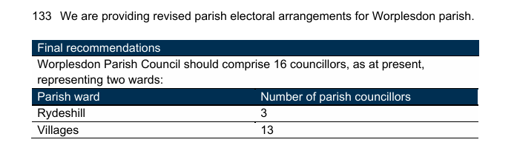
The geographic area of Rydes Hill is outside of the Parish boundary. The Parish Council considered that retaining the proposed ward name of Rydeshill would cause confusion amongst the electorate.

Map 1: Used by the LGBCE to name the ward now sitting within the Guildford West Unitary Ward
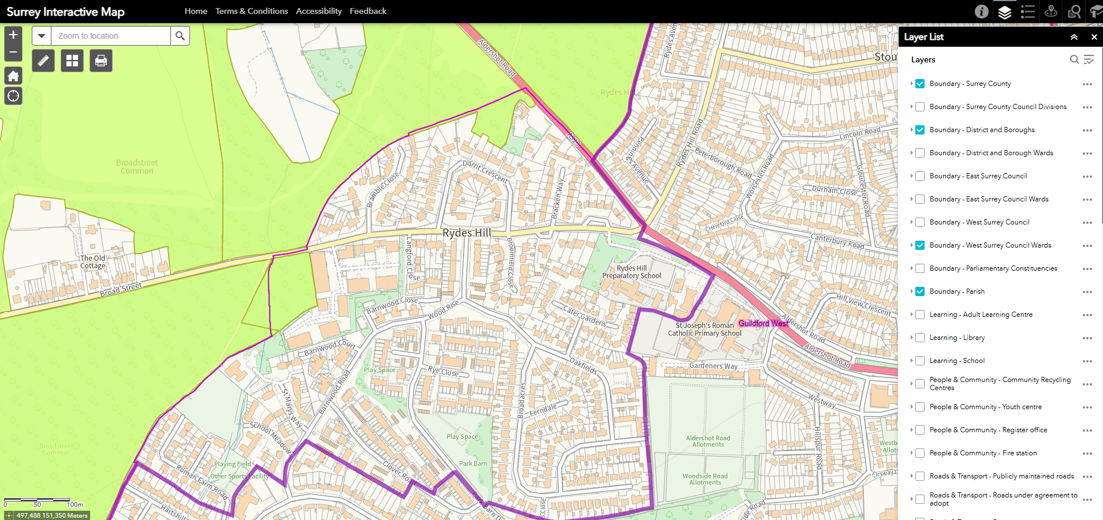
Map 2: Updated Ordnance Survey Map, which shows Rydes Hill in the correct location
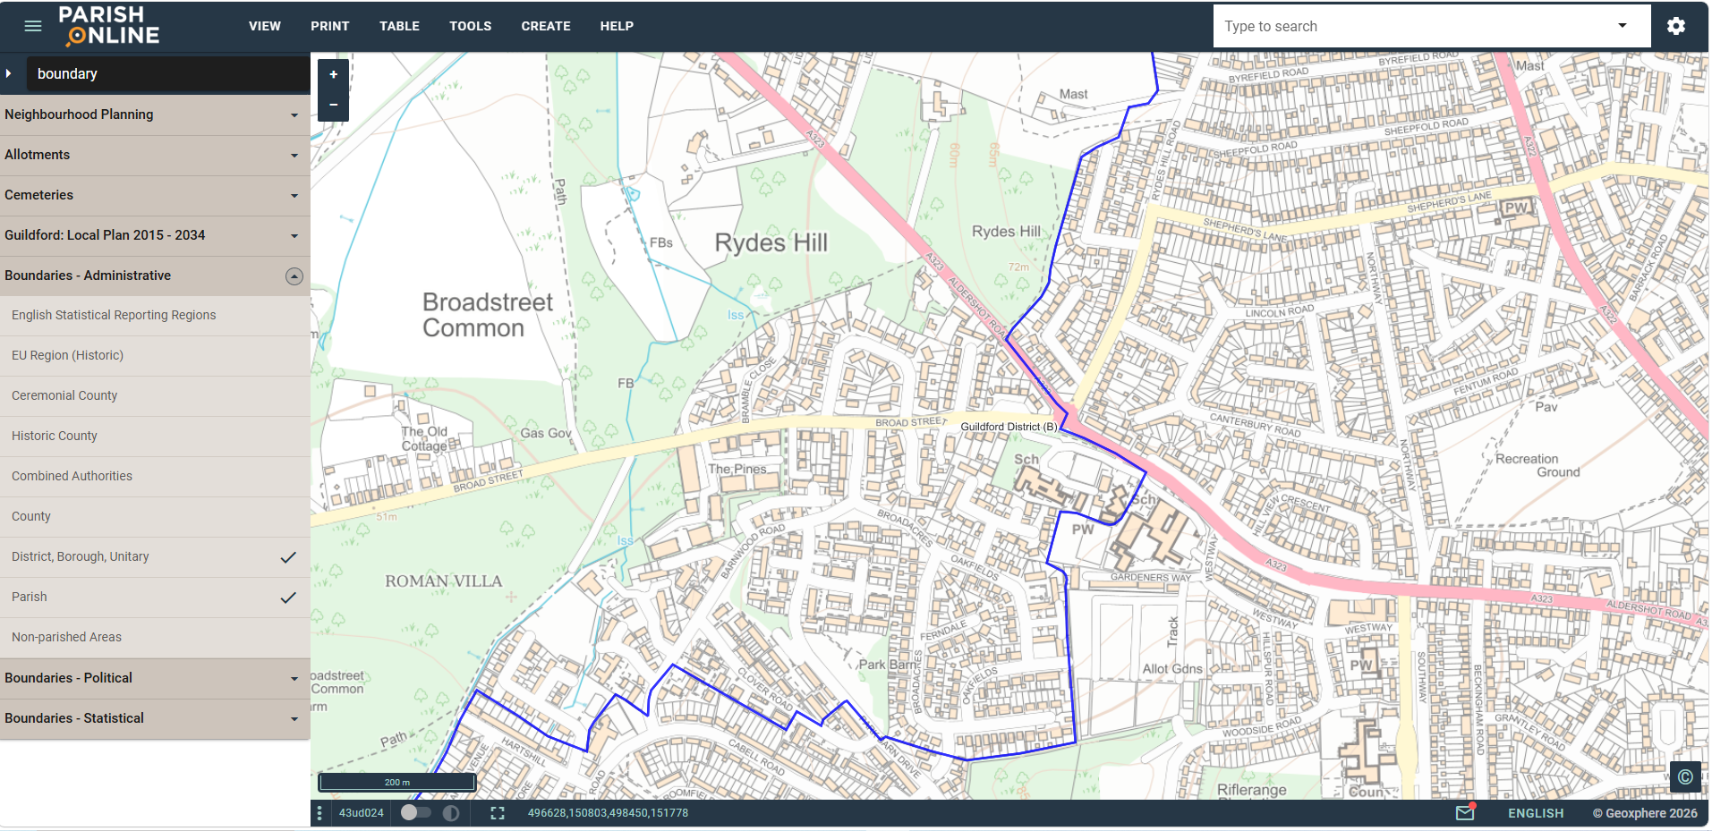

The Councillors considered the proposal for a Community Governance Review (CGR) to be submitted to Guildford Borough Council to facilitate a change to the proposed ward name of “Rydeshill” to “Broad Street”.
It was proposed by Cllr N Mitchell, seconded by Cllr S Busby, and unanimously RESOLVED that a CGR be requested as detailed.

Pinks Hill Pond Future Project
The Clerk outlined the proposed restoration project for Pinks Hill Pond on Broad Street Common, and the available Surrey County Council Nature Recovery grant, for which applications need to be completed by 19 July 2026.
The grant programme offers grants of up to £5,000, and up to £10,000 by exception for 1-2 special projects. The Clerk proposed that to increase the likelihood of a successful grant application, the Parish Council offer £8,000 matched funding to maximise the impact of the proposed project.
It was proposed by Cllr N Crampin, seconded by Cllr T Wright, and unanimously RESOLVED that the project be supported and matched funding of £8,000 be provided by the Parish Council.
Power to spend: PHA 1936, s260

Badges of Office
The Councillors considered the proposal that a Vice Chairman’s Badge of Office could be purchased within the existing allocated budget for the Chairman’s Badge of Office (minute 2025-427 (f) refers). The budget for replacing the Chairman’s Badge of Office was set at £3,000. The estimate for the replacement Chairman’s Badge of Office from Michaels was £1,350. An additional discounted Vice Chairman’s Badge of Office was quoted as £1,125. The resulting total cost was £2,475.
A lengthy debate ensued, following which a vote took place.
Following the debate, it was proposed by Cllr N Mitchell, seconded by Cllr S Busby and RESOLVED that both Chairman’s and Vice Chairman’s Badges of Office be purchased.
- A vote took place for the Chairman’s Badge of Office: 8 supported the proposal. Cllr N Crampin voted against the proposal. Motion carried.
- A vote then took place for the Vice Chairman’s Badge of Office: 4 supported the proposal. Cllr B Ahier, Cllr G Burch, Cllr N Crampin, and Cllr T Wright voted against the proposal. Cllr M Price abstained. Due to the tied vote, the Chairman used his casting vote. The Chairman voted in favour. Motion carried.

Wood Street Village Summer Show
It was requested that the Council consider granting approval in principle to the Wood Street Village Association for the Wood Street Village Show to take place on Wood Street Village Green for the next five years, to facilitate event planning.
At 21:13 Councillor J Steel left the meeting.
It was proposed by Cllr N Mitchell, seconded by Cllr S Busby, and unanimously RESOLVED that the Wood Street Village Association (WSVA) be granted approval in principle for three years from 2027, subject to annual submission of event application forms and completion of appropriate risk assessments.

One-Day Event at Merrist Wood College
An entertainment licence request was received for the Loud Out 2026 event on 29 August 2026 13:00 – 22:30, managed by Debbre Arts and Events showcasing Nepali artists, taking place at Merrist Wood College.
The Councillors confirmed their support, with comment of disappointment that this event was limited to over 18s.

Cloudy IT Training
The Councillors have requested that a face-to-face training session be arranged with Cloudy IT. The proposed dates were 16 or 30 July.
Power to spend: Local Government Act 1972, s. 111

Renewal of Lease, Unit 2 Saxton, Parklands, Railton Road, Guildford, Surrey, GU2 9JX
It is being proposed that an early lease renewal be pursued for the current Parish offices, given the delay of Hester’s Yard, to best align with the expected timelines. The renewal would apply from December 2026 and be for five years, with a break clause at four years, which will hopefully align with the new premises becoming available.
It was proposed by Cllr N Mitchell, seconded by Cllr T Wright, and unanimously RESOLVED that the lease renewal be pursued as detailed.

The future of Guildford’s Shopmobility
An update was received on Guildford’s Shopmobility, stating that Age Concern UK has discontinued its involvement leading to suspension of this service.
Guildford Borough Council do still offer the grant so this service could continue if another charity was willing to take this over, but none have stepped forward.
At 21:29 meeting adjourned.
The standing orders were waived to enable Councillor Julia McShane to address the Council.
Councillor Julia McShane informed the Council that she had met with Ruth House and Shirlee Posner, who were leading on a petition seeking to prevent the closure of Guildford Shopmobility.
Members noted that Guildford Borough Council has confirmed its willingness to support any community group wishing to continue the service. Support available includes access to grant funding and the continued use of the Bedford Road premises at a peppercorn rent. It was further reported that, at present, no alternative community groups have come forward to operate the service. Woking Shopmobility had also been approached but had declined the opportunity.
At 21:34 meeting reconvened.
At 21:34 Councillor J McShane left the meeting.

Finance:

Proposed list of payments to be tabled at the meeting for approval
The payment list was presented to the meeting. It was proposed by Cllr T Wright, seconded by Cllr S Busby, and unanimously RESOLVED that payments to the value of £62,029.43 be approved. The payment list was duly signed by the Chairman, Cllr N Mitchell, during the meeting.

Table 3 – Payment list 02 July 2026
Code | Date | Description | Supplier | Net | VAT | Total
Revenue Costs Works Vehicle | 10/06/2026 | Fuel for works van | Waitrose Shell | 45.07 | 9.01 | 54.08
Land Management | 10/06/2026 | Bulbs for planters at Perry Hill Green | J Parker's Wholesale | 67.95 | 13.59 | 81.54
Parish Office | 11/06/2026 | Cleaning materials for office | Mrs G F White - Must Have Ideas Ltd | 29.97 | 0.00 | 29.97
Pond Maintenance | 11/06/2026 | Great Crested Newt Habit Suitability Index and eDNA Survey | Thomson Environmental Consultants Ltd | 889.75 | 177.95 | 1,067.70
IT budget | 11/06/2026 | Dell Monitor, Webcam, Dell Pro Micro Desktop, set up and postage | Cloudy IT | 1,066.98 | 213.40 | 1,280.38
Parish Office | 11/06/2026 | Rent Unit 2 Saxton - 24.06.26 - 28.09.26 | TL Fund | 7,000.00 | 1,400.00 | 8,400.00
Parish Office | 10/06/2026 | Quarterly service charge 01/04/26 - 30/06/26 | TL Fund | 180.09 | 36.02 | 216.11
Training | 11/06/2026 | Training - Emergency First Aid At Work 26/08/26 MW, VF & HL | British Red Cross | 519.00 | 103.80 | 622.80
Land Management | 12/06/2026 | Fishling Line Pipe Bin | Anglers National Line Recycling Scheme | 54.00 | 0.00 | 54.00
IT budget | 12/06/2026 | Mobile Phone Charges | EE | 90.00 | 0.00 | 90.00
IT budget | 16/06/2026 | Additonal back up | Apple.com | 2.49 | 0.50 | 2.99
Parish Office | 17/06/2026 | Gas & Electricity - Unit 2 Saxton - 26.02.26 - 31.05.26 | Octopus Energy Limited | 75.29 | 3.76 | 79.05
IT budget | 17/06/2026 | Backup,Support,CyberPro,M'Soft365 - 15.06.26-30.06.26 | Cloudy IT | 23.60 | 4.72 | 28.32
Establishment Charges | 17/06/2026 | Office Sundries | Mrs V C Fear - Shanza Ltd (Amazon) | 8.21 | 1.64 | 9.85
Establishment Charges | 17/06/2026 | Items for Community Event | Mrs V C Fear - Amazon EU S.a.r.l., UK Branch | 24.99 | 5.00 | 29.99
Land Management | 17/06/2026 | Mower Line | Mrs V C Fear - Mower Express Limited (Amazon) | 11.91 | 2.38 | 14.29
Land Management | 17/06/2026 | Plants for planters at Perry Hill Green | Mr N Mitchell - Longacres | 51.62 | 10.33 | 61.95
Er's APC | 18/06/2026 | Additional Pension Contribution | The Surrey Pension Fund | 27,000.00 | 0.00 | 27,000.00
IT budget | 18/06/2026 | Subscription - 17.06.26 - 16.07.26 | Adobe | 16.64 | 3.33 | 19.97
IT budget | 18/06/2026 | ChatGPT Plus Subscription | OpenAI LLC | 16.67 | 3.33 | 20.00
Parish Office | 19/06/2026 | Water and sewerage charge - Unit 2 Saxton - 01.05.26 - 31.05.26 | Castle Water | 30.83 | 0.00 | 30.83
Establishment Charges | 22/06/2026 | Office supplies | Sainsburys | 14.00 | 0.00 | 14.00
Donations | 24/06/2026 | Donation 2026/27 | Citizens Advice Bureau | 189.00 | 0.00 | 189.00
Land Management | 24/06/2026 | Plastic Hosetail Kit | Kingfisher Direct Ltd | 22.00 | 4.40 | 26.40
Land Management | 24/06/2026 | Metal paint | Brewers Decorator Centres | 282.34 | 56.47 | 338.81
Establishment Charges | 24/06/2026 | Job Advert | SLCC Enterprises Ltd | 313.00 | 62.60 | 375.60
Parish Newsletter | 24/06/2026 | 3,600 newsletters and Annual Reports | Knaphill Print Co Ltd | 713.00 | 0.00 | 713.00
Staff Costs | 24/06/2026 | Salaries/ PAYE/ NI/Pension Conts Ee's & Er's | Staff Costs | 19,444.76 | 0.00 | 19,444.76
Staff mileage | 24/06/2026 | Mileage | Mrs V C Fear | 15.60 | 0.00 | 15.60
Staff mileage | 24/06/2026 | Mileage | Mrs G F White | 61.10 | 0.00 | 61.10
Staff mileage | 24/06/2026 | Mileage | Miss M Wingate | 31.85 | 0.00 | 31.85
Tree Surgery | 25/06/2026 | Lift lower branches - Coombe Lane, Perry Hill | Lumber-Jacks Tree Services Ltd | 100.00 | 20.00 | 120.00
Tree Surgery | 25/06/2026 | OPM nest removal x3 | Lumber-Jacks Tree Services Ltd | 200.00 | 40.00 | 240.00
Revenue Costs Works Vehicle | 26/06/2026 | Fuel for works van | Waitrose Shell | 57.54 | 11.51 | 69.05
Bank Interest/Charges | 26/06/2026 | Bank charges - May 2026 | Metrobank | 3.00 | 0.00 | 3.00
Land Management | 30/06/2026 | Painting materials | Screwfix Direct Ltd | 27.63 | 5.53 | 33.16
Bank Interest/Charges | 30/06/2026 | Bank charges - May 2026 | Unity Trust Bank | 7.00 | 0.00 | 7.00
Parish Office | 01/07/2026 | Business rates - Parish Office | Guildford Borough Council | 1,027.65 | 0.00 | 1,027.65
Community Car Park | 01/07/2026 | Business rates - Community Car Park | Guildford Borough Council | 89.35 | 0.00 | 89.35
Revenue Costs Works Vehicle | 01/07/2026 | Service plan - 30th instalment of 45 | PlanMyService LLP | 27.08 | 5.42 | 32.50
Revenue Costs Works Vehicle | 01/07/2026 | MOT Service plan - 30th instalment of 45 | PlanMyService LLP | 3.78 | 0.00 | 3.78
 |  |  |  | 59,834.74 | 2,194.69 | 62,029.43

Bank reconciliation May 2026
The Finance Officer (FO) had prepared the bank reconciliation for May 2026 in accordance with the Accounts and Audit Regulations, a copy of which had been issued to all Members via email in advance of the meeting. It was proposed by Cllr M Price, seconded by Cllr N Crampin, and unanimously RESOLVED that the bank reconciliations be approved and signed by the Chairman, Cllr N Mitchell, during the meeting.
Appendix 2: Bank Reconciliation May 2026

Monthly budget reports for May 2026
The FO had prepared the budget reports for May 2026 in accordance with the Accounts and Audit Regulations, copies of which had been issued to all Members via email in advance of the meeting. It was proposed by Cllr S Busby, seconded by Cllr B Nagle, and unanimously RESOLVED that the budget reports be approved and signed by the Chairman, Cllr N Mitchell, during the meeting.
Appendix 3: Monthly Budget Report (Summary) May 2026

Quarterly Financial Check – 24 June 2026
Cllr M Price gave the following report:
On 24 June, myself and Nuala Crampin reviewed the bank statements for the period 1 March 2026 to 31 May 2026, and found them to be in agreement with the Bank Reconciliation documents, payment schedules, and invoices for the same period, as well as the transfer of funds between various accounts, together with the receipt of the first tranche of the precept payment from Guildford Borough Council.
At the same time, we checked the paying/cheque books for the various accounts, as well as the VAT and payroll files.
My thanks once again go to Councillor Nuala Crampin who assisted me with the above review, and also Helen Lawrence (FO) for providing all of the necessary documentation.
It was proposed by Cllr B Ahier, seconded by Cllr C Riley, and unanimously RESOLVED that the report be approved and accepted.

Co-operative Bank Approver
The request was made to add Assistant Clerk Victoria Fear to the Co-Operative Bank as an approver for business continuity purposes.
It was proposed by Cllr B Nagle, seconded by Cllr S Busby, and unanimously RESOLVED that the request be approved and accepted.

Clerk to the Council
Bank Mandate Updates – Retirement of Gaynor White
The Council noted that the Clerk to the Council and Responsible Financial Officer, Gaynor White, will retire on 31 August 2026 following 27 years' service. The Council further noted that Marie Wingate was appointed to the Council on 8 June 2026 and will assume the roles of Proper Officer (Clerk to the Council) and Responsible Financial Officer upon the retirement of the current postholder.
It was proposed by Cllr B Nagle, seconded by Cllr S Busby and unanimously RESOLVED that the authorised signatories and account mandate details for the Council's bank and building society accounts be updated to reflect the change in the Council's Proper Officer and Responsible Financial Officer. Accordingly, Gaynor White shall be removed as an authorised signatory and key contact, and Marie Wingate shall be added as an authorised signatory and key contact for the following accounts:
• Cambridge Building Society
• The Co-operative Bank
• Metro Bank
• Nationwide Building Society
• Skipton Building Society
• Unity Trust Bank

The Clerk to the Council/Financial Officer was authorised to complete, sign and submit all documentation required by the above financial institutions to give effect to these changes.

Double Flush end of project report received
The report was received, for information only.

Clerk’s Report

Guildford Borough Council Local Plan

-
Guildford Borough Council has announced its formal timetable.

Planning enforcement number EN/26/00096 Clay Lane
- - A stop notice has been served which comes into effect 8 July. If the notice is not appealed those served will have 9 months to comply with the requirements.

Introductions and meetings attended by Marie Wingate and Gaynor White

-
The incumbent Clerk reported on the meetings and introductions which have been attended by herself and the new Clerk.

OPM Nests in Harry’s Meadow
- Oak Processionary Moth (OPM) nests were identified across the Parish in the annual tree survey. These have been reported to The Forestry Commission, and specialist contractors have been engaged to remove the OPM nests.

The Clerk to the Council’s SLCC membership will transfer from Gaynor White to Marie Wingate on 1 September 2026

-
SLCC have been contacted and confirmed an additional membership would not be required, as the existing Clerk’s membership can be transferred on 31 August 2026.

Re-development of Dennis Way, Slyfield Industrial Estate
- The appeal has been dismissed.

Chairman’s Report
This report covers the period from 21 May to 1 July 2026.
Community Speedwatch
Community Speedwatch deployments have continued throughout the reporting period. Initial observations at deployment locations suggest that the number of speeding offences is reducing.
Badge of Office
Discussions have continued with an alternative supplier regarding the provision of a new Chairman's Badge of Office. The proposals remain within the budget approved by the Council. There is also scope to provide a Vice-Chairman's Badge of Office whilst remaining within budget, should Members wish to consider this.
21 May
- I chaired the Annual Meeting of the Council and thank Members for their assistance in completing the agenda efficiently.
26 May
- I met with the Clerk Gaynor White to discuss her forthcoming retirement and the arrangements for the recruitment of her successor.
27–29 May
- I served on the interview panel for the recruitment of the new Clerk, together with Cllrs Mike Price and Jonathan Snowball, the Clerk Gaynor White and the Assistant Clerk Victoria Fear. Following the interview process, Marie Wingate was appointed as the new Clerk in training to Worplesdon Parish Council.
5 June
- I chaired the Extraordinary Meeting of the Council, at which Members formally approved the appointment of the new Clerk Marie Wingate and resolved to make an additional pension contribution in recognition of the retiring Clerk Gaynor White's 27 years' service.
8 June
- I attended the office on Marie's first day to complete the formal employment documentation and welcome her to Worplesdon Parish Council.
10 June
- The Officers Gaynor White, Marie Wingate, Andy Connor and I met with the Council's newly appointed Volunteer Fisheries Bailiff, Matt West, to discuss the Council's educational approach to responsible fishing at Wood Street Village Pond. Matt has now been issued with Council identification and branded clothing.
11 June
- I attended the General Purposes Committee meeting.
15 June
- I met with Wendy Staniforth of Merrist Wood College to select suitable perennial shrubs for one of the Perry Hill planters. The planting will enhance biodiversity, provide seasonal interest and help screen the adjacent utility box. My thanks go to Cllr Geoff Burch for watering the shrubs following planting.
That evening I attended the Cluster Meeting with Pirbright and Normandy Parish Councils, accompanied by Gaynor White and Marie Wingate. Topics discussed included Local Government Reorganisation, election costs, Merrist Wood Golf Club, the Horse Field at Salt Box Road and unauthorised encampments.
16 June
- That evening I attended the Whitmoor Common Association Annual General Meeting with Gaynor White and Marie Wingate. Surrey Wildlife Trust provided updates on habitat management, conservation grazing and proposed wildfire detection measures across Whitmoor Common.
17 June
- I attended the Surrey Association of Local Councils (SALC) Councillor Forum. Updates included Local Government Reorganisation, the May 2027 parish elections, planning matters, councillor training, community resilience grants and cyber security.
19 June
- Following the Extraordinary Meeting on 5 June, the approved additional pension contribution was paid to Surrey Local Government Pension Scheme. The Clerk, Gaynor White, subsequently confirmed her intention to retire on 31 August 2026.
22 June
- I formally acknowledged the Clerk Gaynor White's notice of retirement on behalf of the Council.
Strategic Business Plan
A review of the Strategic Business Plan is required, for consideration for the next Electoral Budget.
The Working Party for the Strategic Business Plan has been arranged for 13 July 2026 at 2pm.

Items for inclusion on future agendas
None were proposed.

Clerk’s Retirement
The existing Clerk’s retirement date was confirmed as 31 August 2026.

Date of next Full Council Meeting
- Thursday 13 August 2026 - 19:30.

Meeting closed 21:54

Signed:

Chairman of the Council
13 August 2026

