Residents’ Online Survey Autumn 2021

Please complete our survey to enter into a
PRIZE DRAW FOR A LUNCH FOR TWO PEOPLE AT THE JOLLY FARMER, WEDNESDAY TO SATURDAY

KINDLY SPONSORED BY THE JOLLY FARMER, WORPLESDON
http://www.jollyfarmerworplesdon.co.uk
Welcome to the Worplesdon Parish Council Survey.

The Parish Council is the first tier of local government. It comprises sixteen councillors (although there are currently two vacancies) and three members of staff, two of whom are part time. The Councillors are all unpaid holders of public office, with legal responsibilities.

Worplesdon Parish Council provides a varied range of services. This is your chance to have a say about those services, so please let us know your views. There is a space for comment in the main body of the survey and also at the end, where you can elaborate on issues, share your thoughts, and make suggestions.

All parish residents aged 16 and over are invited to take part.

Completing the questionnaire

The questionnaire will be available for four weeks from Wednesday 1 September until midnight on Thursday 30 September 2021.

This is predominantly an online survey, although paper copies can be provided, on request. The survey is available via the following link: https://worplesdon-pc.gov.uk/facilities/residents-survey-2021/. Please download and complete the survey. Completed surveys can be emailed to admin@worplesdon-pc.gov.uk or posted to Worplesdon Parish Council, Unit 2 Saxton, Parklands, Railton Road, Guildford, Surrey, GU2 9JX.

The purpose of the survey is to provide feedback to inform the setting of the parish element of your council tax for the financial year 2022/2023. The results of the survey will be made available early November 2021 on our website and in our Winter 2021 newsletter.

These are the areas for which Worplesdon Parish Council has direct responsibility:

Wood Street Village community car park, bus shelters, litter bins, planning responses, Worplesdon Community SpeedWatch Scheme, Speed Data Recorders and Vehicle Activated Signs, Jacobs Well war memorial, Christmas lights and trees, land management (land owned by and leased to the parish council), devolved land maintenance (clearing of certain ditches, sightlines), benches, Worplesdon Flood Forum, village signs, parish noticeboards, various events (including the annual Armistice Day wreath laying ceremony), sign cleaning, play areas and grants to local organisations.

Other areas are the responsibility of Guildford Borough Council, such as planning and licensing, or Surrey County Council, for highways, buses, and education. Further clarification is available on the parish website: https://worplesdon-pc.gov.uk/your-council/about-us/.

The map below shows the parish boundary, and also the electoral ward boundaries, as your ward is relevant to some questions:
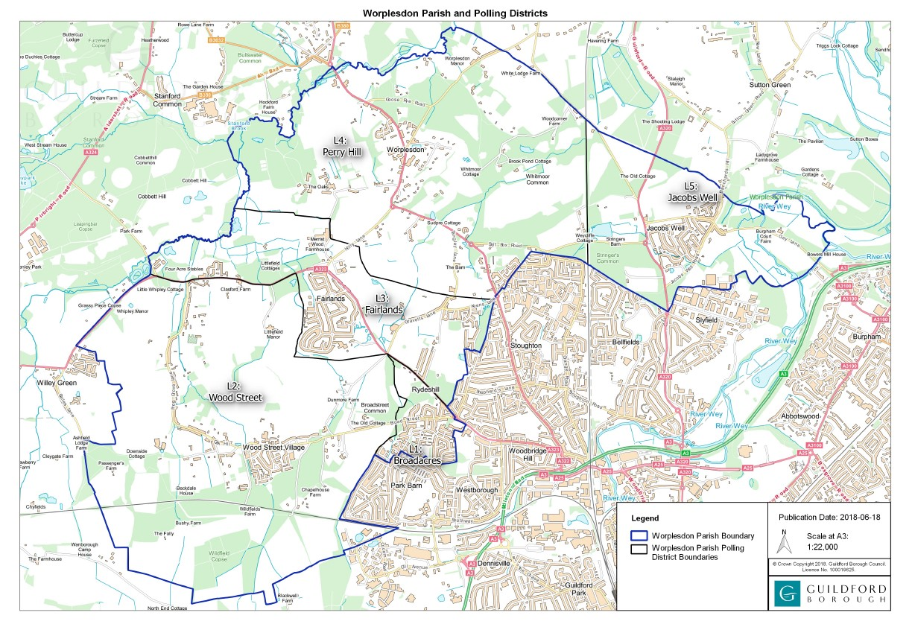

Demographics

The Parish Council would like to have a better understanding of the parish demographics.

1a) How many people live in your household:

1b) Please can you indicate their age bands and the number in each band:

0 - 4 yrs
5 - 9 yrs
10 -18 yrs
18 - 25 yrs
26 - 35 yrs
36 - 45 yrs
46 - 55 yrs
56 - 65 yrs
66 - 75 yrs
76 - 85 yrs
85 yrs +

Loneliness

The Parish Council wishes to get an understanding of how loneliness may be impacting our residents. There are a number of local charities who can offer help.

No-one in my household suffers with loneliness
I/or someone in my household suffers with loneliness.

Playgrounds

Worplesdon Parish Council owns and maintains three play areas across the parish: These are located behind the Fairlands Community Centre, in the Worplesdon Memorial Ground and in the Jacobs Well Recreation Ground.

3a) Do your family use these facilities?
Yes
No

3b) If your family use the play areas, are you satisfied with the facilities?
Yes
No

3c) Which of the play areas do you use?
Fairlands
Jacobs Well
Worplesdon

3d) If your family don’t use the play areas, is there a reason why not?

Please comment further in the box below if you wish:

3e) Subject to funding availability, and the physical space being available within the play area, would you like
to see the facilities improved? If so, please specify in the box below.

Grass Cutting

Surrey County Council owns all grass verges across the County. The County Council’s existing Agency Agreements in respect of the verge cutting expire 31 March 2022. Currently, Worplesdon Parish Council
acts as the County Council’s agent in respect of grass cutting in the parish.

In 2019, Surrey County Council declared a Climate Emergency. The County Council is keen to improve biodiversity and wishes to reduce the number of cuts being undertaken across the Parish.

There is a new initiative being promoted by Surrey County Council called the Blue Campaign. Where suitable, with the support of residents, a blue heart can be displayed on certain verges to reduce grass cutting to once per year and thereby encourage biodiversity. Cutting would continue to maintain sight lines and clear foot/cycle paths. Please see the following website link for further information:

https://www.surreycc.gov.uk/roads-and-transport/roadworks-and-maintenance/trees-grass-and-hedges/grass/the-blue-campaign-increasing-biodiversity-in-grass-verges

4a) Would you support a trial Blue hearts scheme in the Parish?
Yes
No

4b) Assuming Worplesdon Parish Council is permitted to continue to act as agents for the County Council in respect of grass cutting, would you prefer four or two cuts to be carried out per annum?
Four cuts
Two cuts

Please comment further in the box below if you wish:

Please indicate the ward in which you live by ticking the relevant box below:
Fairlands
Jacobs Well
Perry Hill
Wood St Village

Please comment further in the box below if you wish:

SpeedWatch initiative

The Parish supports a Community SpeedWatch scheme in designated areas approved by Surrey Police.

5a) Are you aware of this scheme?

Yes
No

5b) If you are aware of the scheme, do you think it is useful in influencing driver behaviour?

Yes
No

Please comment further in the box below if you wish:

Vehicle Activated Speed signs
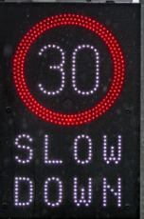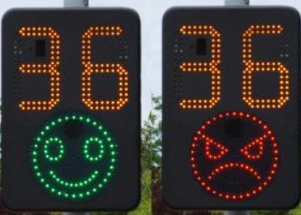
Due to limited Community SpeedWatch deployments, additional vehicle activated signs, could be purchased and located at police approved sites across the Parish.

6a) Would you support the inclusion in our annual budget for each of the next three years a sum, not exceeding £5,000 per annum, so that Worplesdon Parish Council can purchase new vehicle activated signs and associated equipment such as batteries and/or solar panels?

Yes
No

Public area litter bins

Guildford Borough Council is the cleansing authority for the borough. However, due to financial pressures, they are no longer able to meet the cost of emptying litter bins not on the public highway, or those on privately owned land. From 1 April 2021 Worplesdon Parish Council is required to fund the cost of emptying fourteen litter bins on land for which the Parish Council is directly responsible. The annual cost for emptying these litter bins on a weekly basis will be £2,700 & VAT.

7a) Are you satisfied with the amount of litter bins provided across the parish?

Yes
No

7b) Are you satisfied with the frequency of collection?

Yes
No

7c) Would you be willing to support more tax-payer’s money being spent on the provision of, and emptying of additional litter bins?
Yes
No
Please comment in the box below if you wish.

Additional services

As a Parish Council, we now carry out additional services which are not our statutory responsibility, for example clearing up alleyways, cleaning road signs, clearing ditches, and cutting back sightlines.

8a) Do you support this additional service and cost to the Parish?

Yes
No

8b) Of the services delivered by the Parish Council, please tell us which services you value the most.

8c) Is there anything else you would like to suggest that the Parish Council can consider for next year’s expenditure that you think would benefit the residents of the parish (excluding highway projects)?

Green Spaces

Worplesdon Parish Council is responsible for maintaining the following Green Spaces:

  - Pitch Place Green
  - Perry Hill Green
  - Wood Street Village Green
  - Nevins Copse, Pinks Hill, Wood Street Village
  - Jacobs Well Recreation Ground
  - Harry’s Meadow, Jacobs Well

9a) Would you like the Parish to rent these spaces out more actively for commercial purposes?

Yes
No

Please comment further in the box below, if you wish.

Public Transport

Although the Parish Council has no authority in relation to the provision of public transport, please can you indicate if public transport is important to you.

Yes - Bus services

Yes - Train services

No

Surrey County Council is currently consulting on its draft Transport Plan. You can have your say by visiting
https://surreyltp4.commonplace.is/ to help shape the measures required to meet the County Council’s net zero challenge. Please submit your views to Surrey County Council by 11:59pm on 24 October 2021.

Parish Office

The Parish Council hopes to be able to secure a permanent office, in due course, through the receipt of section 106 funding. In the meantime, we are renting facilities which include a 500sq ft meeting room and kitchenette.

11a) Would you, or your community group, be interested in hiring the meeting room for meetings, during office hours, when not in use by the Parish Council?

Yes
No

If yes, please provide your email address: ……………………………………………………………………………………………..
Or phone number: ………………………………………………………………………………………………………………………………..

Social Media

12a) Are you aware that Worplesdon Parish Council has social media pages via Facebook and Twitter?

Yes
No

12b) Which platform, if any do you use?

Facebook
Twitter
Instagram
None
Other, please specify

Please comment further in the box below if you wish.

12c) We currently disseminate details about road works, public consultations from the borough and county councils, local events and other items of general interest. Are there any other items you would like us to include on these social media pages?

Please comment further in the box below, if you wish:

Volunteering

We know that Parishioners already volunteer for a range of organisations and charities. Would you be interested in volunteering in the Parish for Community SpeedWatch or outdoor working parties?

Community Speed Watch
Alleyway and path clearance work parties

If yes, please provide your email address or phone number at the end of the survey.

Jacobs Well Play Area

Worplesdon Parish Council has received numerous complaints about the lack of parking for the Jacobs Well play area. Would you support the provision of, up to four parking spaces in the Recreation Ground, subject to the costs and appropriate permission being obtained from the Secretary of State for DEFRA under s38 of the Commons Act 2006?

Yes
No

General comments

Do you wish to comment on anything else? Have you any thoughts or suggestions (relating to the whole Parish or a specific ward) which you would like to share with us? Please comment in the box below.

If you wish to enter into the prize draw or for us to contact you about any items raised within this survey or to volunteer, please provide your contact details below:

Name: ………………………………………….…………………….

Email address: …………………………………………………….

Postal address: …………………………………………………………………………………………………………………………………………………….…

……………………………………………………………………………………………………………………………………….……………………………………….

Phone number: ……………………………………………………

Data Protection:
Any personal information given via this survey will only be used to enable the Parish Council to assess its services, or to contact you about issues you’ve highlighted that you would like to be contacted about specifically and will not be disclosed to any other third party without your prior permission or unless we are required to do so by law. This information will be securely retained, except for hardcopies which will be securely destroyed after 12 months.

Thank you for taking the time to complete our survey.

